ĐỀ THI TIẾNG ANH Mã đề: 06
Trình độ A2
Họ và tên thí sinh: ……………..……………………………………………………….…………………………………………………………
Số báo danh: ……………..…………………………………………...……. Phòng thi số: …………………………….……………

PAPER TWO LISTENING (Approximately 15 minutes)
PART 1: Questions 1 – 5
There are five questions in this part. For each question there are three answer choices and a short recording. Tick (√) the correct answer. You will hear the piece twice.
Example: How many people were at the meeting?
A. 3 B. 13 √ C. 30
1. When will they go on holiday?
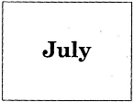
A □ B □ C □
2. How is Patty going to travel?
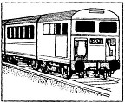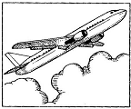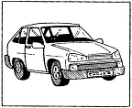
A □ B □ C □
3. What will Sam do?
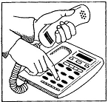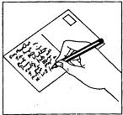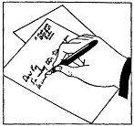
A □ B □ C □
4. What was the weather like in Portugal?
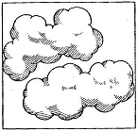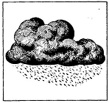
A □ B □ C □
5. What has the girl broken?
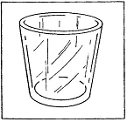 `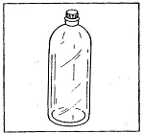 
A □ B □ C □
PART 2: Questions 6-10
Listen to Sarah talking about a sports centre. What is the problem with different things at the sports centre?
For questions 6-10, write a letter A-H next to each person. You will hear the conversation twice.

EXAMPLE | ANSWER
0 T-shirt | A
THINGS |  | PROBLEMS
6 swimming pool  7 car park  8 cafe  9 football club  10 tennis lessons |  | A big  B cold  C dirty  D expensive  E hot  F late  G noisy  H small

PART 3: Questions 11-15
Listen to Jenny asking Mark about school holiday activities.
For questions 11-15, tick (√) A, B, or C. You will hear the conversation twice.
Example: 0. The chidren’s show is at
A. the theatre
B. the shopping centre
C. the library

11. The show begins at
A. 1.15
B. 2.00
C. 3.30
12. A child’s ticket costs
A. 25p
B. 75p
C. £1.50
13. The holiday reading course is for
A. 4 weeks
B. 6 weeks
C. 10 weeks
14. This year from the library, children can win
A. a pen
B. a school bag
C. a book
15. Jenny should meet Mark agian
A. next week
B. tomorrow
C. today

